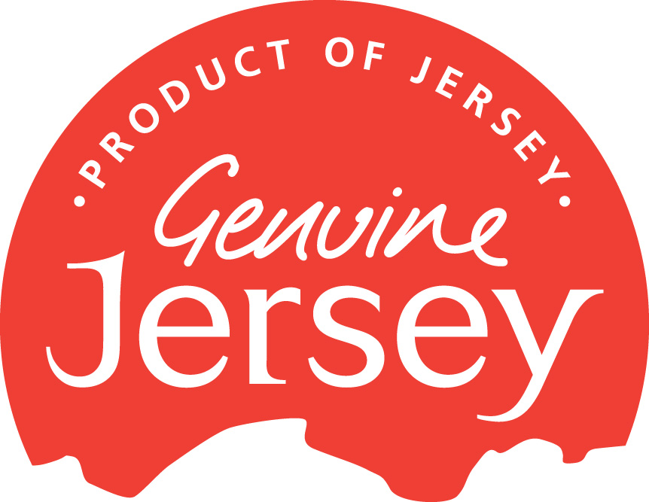

The Genuine Jersey Charter

1 INTRODUCTION

- Genuine Jersey is a scheme whose purpose is to identify and promote locally grown, reared or caught goods and those products and services which are made or offered in Jersey and thus be regarded by consumers as being genuinely local.
- The terms and conditions of this Charter provide the governing framework for the use of the Genuine Jersey mark which may be granted to, withheld or withdrawn from any applicant or member.
- The governing authority for the use of the Genuine Jersey mark is the duly appointed Management Committee of the Genuine Jersey Products Association.
- The Genuine Jersey mark is, collectively, (a) the expression GENUINE JERSEY simpliciter (regardless of case, colour or graphic presentation) and (b) the Genuine Jersey logo as published. The latter, ordinarily, may only be reproduced in its standard colours (Pantone Blue 072C, Pantone Red 032C, Pantone Green 347C, and Pantone Gold 873C) or rendered in monochrome. However, the latter mark may be reproduced in alternative colours to suit labelling or packaging designs subject to approval by the Management Committee. The mark may not be modified in any way and the copyright and conditions governing its use remain with the Management Committee.
- The Genuine Jersey mark may be affixed (by printing, transfer or other appropriate method) to goods provided such goods have been approved by the Management Committee as qualifying under these terms and conditions (as amended from time to time). The mark may not be used in advertising, point of sale, promotional literature and stationery except where it is shown on goods or where it is used in conjunction with the word ‘Member’ or the phrase ‘A Member of Genuine Jersey’. Any other application within an advertisement or promotion requires the approval in advance of the Management Committee or Chief Executive Officer. It is a condition of use that the mark shall not be used in any printed advertisement or printed publicity matter directed primarily to the market in the United Kingdom and in the Isle of Man or in retail point of sale display cards distributed by the Registered Proprietor for use within the United Kingdom and in the Isle of Man without indicating that it is a Collective Mark.
- As a rule the Genuine Jersey mark should not occupy more than 10 per cent of any given area on any one side of packaging or product. Any design which is likely to breach this rule must first receive the approval of the Management Committee or Chief Executive Officer.
- The Genuine Jersey Products Association will provide for its members point of sale material and rolls of adhesive labels of the mark at no more than cost. Artwork for the use of the mark as part of a pack design or appropriate labelling will also be available at no more than cost.
- The Genuine Jersey Products Association may publicise the scheme in appropriate media at the discretion of the Management Committee.

2 GENERAL

  - Organisations based in Jersey and making, rearing, growing or catching goods or offering services in Jersey and its surrounding waters may apply to have their goods or services assessed as qualifying to carry the Genuine Jersey mark. Such organisations will, if the products or services are approved, become members of the Genuine Jersey Products Association.
  - Membership may also be granted to kindred associations subject to the following conditions:
    - Individual members of such associations may only use the Genuine Jersey mark as specified in this Charter:
    - The responsibility for ensuring compliance with the terms of usage rests with the member association but shall be open to inspection by representatives of the Genuine Jersey Products Association.
    - Those products or services carrying the Genuine Jersey mark must be identified and approved by the Genuine Jersey Products Association and so registered by the member association at the time of application – additional products or services that meet the Genuine Jersey Products Association criteria may be added from time to time by separate application.
    - Kindred associations shall pay a membership fee as a corporate body. Members of those associations who wish to use the Genuine Jersey mark in their own right may do so upon payment of a supplementary fee, such fee to be determined by the Management Committee and subject to annual review.
    - In the event of a breach of rules of usage of the Genuine Jersey logo (and such breach being confirmed by the Management Committee), the use of the mark may be withdrawn from that kindred association member, it being a condition of such membership that this will occur.
    - In all other matters the kindred association members shall be bound by the rules of the Association.
  - Applications for membership shall be made on an application form an example of which is appended hereto and which example shows typical annual fees and fee structures. Membership, whether as described in 2.1 or 2.2 above, shall be by an annual subscription liable to annual review and any changes shall be proportionate to the subscription levels shown on the appended example.
  - The management of the Genuine Jersey Products Association will be by a committee (the Management Committee) which will apply these terms and conditions to applicants and be responsible for determining the policies of the Association.
  - The composition of the Management Committee shall be as follows:
    - an independent chairman and vice-chairman appointed by the Management Committee and not drawn from scheme members. These members will serve a two year term and be appointed or re-appointed in alternating years,
    - three members from scheme participants to be elected by the membership for a three year term, each member to be elected (or re-elected) on consecutive years,
    - three appointees of the Economic Development Department to include a Trading Standards Officer, to serve as directed by the Economic Development Department,
    - the Management Committee shall also invite the Jersey Farmers Union to appoint a member to serve on the Committee,
    - the Management Committee may also appoint, at its own discretion, a representative of any other appropriate sector,
    - the chief executive of the Management Committee will be the appointed Executive Director of JPPL who will be responsible for the day-to-day management of the Genuine Jersey Products Association including secretarial and financial administration, member liaison, marketing and merchandising. If deemed appropriate the chief executive (in consultation with the Management Committee) will appoint a public relations and/or advertising co-ordinator, this appointment being remunerated and subject to annual review. The chief executive will attend meetings of the Management Committee as a matter of course but will not usually have a formal vote in any deliberations of the Management Committee (when procedure requires a vote to be taken) unless specifically invited to do so by the Chairman,
    - all Committee Members (excluding the chief executive) will have an equal vote including appointees under 2.5.5 and in the event of a tie of votes amongst the voting membership; the Chairman will have a further discretionary casting vote,
    - any appointees with specific roles (e.g. PR/advertising) will prepare reports for discussion at Management Committee meetings but may only attend if requested to do so.
  - In general, goods or services will qualify as being appropriate to carry the Genuine Jersey mark if they:
    - comply with all relevant legislation and the current assessment criteria applied by the Management Committee, i.e. applicants wishing to sell produce will need to meet, and be in possession of, the codes of good agricultural and environmental practice and where they are using agro chemicals hold a National Proficiency Test Certificate (NPTC) or similar.
    - are designed and produced entirely in Jersey using exclusively local raw materials and skills,
    - are grown in Jersey from seed or acceptable imported stock
    - are designed and produced in Jersey not necessarily of local raw materials but where there is evidence of a level of skill and design showing the individuality of the designer/maker,
    - are produced in Jersey where a local component is the reason for the product being produced and using local skills in its production,
    - are produced, developed, grown or reared in Jersey from imported stock but where local skill, husbandry or some other distinctive element unique to Jersey plays the predominant role in production,
    - are services rendered entirely by Jersey based individuals or entities even if such services are rendered to non-Jersey based individuals or entities.
  - Restaurants may apply for membership where they have dishes on the menu which contain at least 80% local ingredients. Such dishes only may be identified on the menu with the Genuine Jersey mark.
  - As a matter of course approval will be subject to a presumption of the highest quality compatible with the product profile and evidence being available that proves that quality control procedures are in place and maintained on a continuing basis. The Management Committee will reserve the right to assess such quality controls as and when deemed appropriate.
  - As a matter of course approval will not be granted to:
    - goods where the only process to which they are subject in Jersey is assembly of ready-made imported components where no recognisable skill is involved and/or packaging and/or the only local raw material, component or ingredient (of a range of other materials, components or ingredients) is water,
    - goods where, despite the use (to whatever extent) of local materials or constituents, the production process is carried on outside Jersey,
    - goods which do not conform to statutory requirements.
  - The decision as to whether or not a product or services qualifies to carry the Genuine Jersey mark remains exclusively with the Management Committee whose decision is final subject to appeal and this body reserves the right to refuse any application. However, any organisation may appeal to the Management Committee on behalf of a particular product or service giving, in writing, the reasons for so doing. If necessary the Management Committee may convene an Appeals Board, made up of three persons, drawn at random from persons who are non-members with an independent chairman. The role of the Appeals Board will be to determine whether or not the Management Committee has complied with the rules in both word and spirit and will be the final arbitrator in the matter.
  - Products or services qualifying to use the Genuine Jersey mark may be subject to annual review to ensure continuing compliance with this Charter. The Management Committee or its designated representative may also have the right to carry out spot inspections to ensure that goods or services continue to comply with the terms under which use of the mark was granted in the first instance.
  - Applications for membership of the Genuine Jersey Products Association are to be made on the appropriate form in the name of an organisation or individual who must be prepared to provide evidence of the qualification of the goods or services for application. Membership of the Association will only be granted and continued where goods or services currently exist. It is the goods or services, not the producer, that are permitted to carry the mark and where a member introduces new goods or services, separate application(s) must be made although no further subscription is payable. The Management Committee may also request an applicant to furnish further or fuller relevant details as it may require and may withhold any specific permit to use the mark (where the applicant is already a member) on a particular product if such further information is not finalised.
  - Membership of the scheme will involve maintaining a list and categorising all goods or services produced by the organisation which qualify for inclusion. Membership of the scheme does not confer on all goods or services produced by that organisation the automatic right to be classified as Genuine Jersey.

3 CONDITIONS

- The use of the Genuine Jersey mark neither implies nor accepts any liability on the part of the Genuine Jersey Products Association for defective products or services offered by members of the Association exhibiting the mark or otherwise howsoever arising.
- The use of the Genuine Jersey mark does not prejudice the statutory and non-statutory legal rights of customers who purchase goods or services from scheme members.
- Members of the Genuine Jersey Products Association agree to be bound by the terms of this Charter and to pay such subscriptions that the Management Committee shall from time to time determine.
- Members of the Genuine Jersey Products Association undertake not to use the mark in any way that would bring the scheme into disrepute.
- Members of the Genuine Jersey Products Association undertake not to use the mark in any way which misleads the public.
- Members of the Genuine Jersey Products Association undertake to abide by high standards of service and quality to ensure customer satisfaction.

4 MISCELLANEOUS

- The Management Committee reserves the right to amend the terms of the Genuine Jersey Charter at any time but any such change will require notification to the full membership, and if requested, the convening of a special general meeting to ratify the change.
- Decisions by the Management Committee on all matters to do with these terms, including but not limited to interpretation, shall be final, subject to the appeals procedure detailed in 2.10.
- The right to use the mark on goods or services may be withdrawn by the Management Committee at any time for a breach of the terms of this Charter or non-payment of subscription within 90 days of written demand. Notice of such withdrawal will be subject to a reasonable period of notice and is also subject to the appeals procedure.
- Members may resign from the Association at any time upon giving written notice and which notice will include agreement that there will be an immediate cessation of the use of the Genuine Jersey mark.
- DISSOLUTION - If the members of the Genuine Jersey Products Association (hereinafter referred to as ‘the Association’) resolve by a majority of seventy-five per cent of the members present and voting at a meeting of the Association, that the Association shall be dissolved, any assets remaining, after the satisfaction of all proper debts and liabilities, shall be transferred to such other society or charity (preferably having objects similar to those of the Association) as the membership may decide, or in the absence of such choice shall be transferred to the Association of Jersey Charities for its general charitable purposes, provided always that no resolution to dissolve the Association shall be considered unless it has prior approval of the Management Committee.

© Genuine Jersey Products Association ~ June 2001 / Amended March ’04 / October ’04 / December ’04 / March ’05 / March ’06 / March ‘07 / November ‘08 February ’10 / June ‘11/ January ‘12/ March ’13

