Promotional Mechanics
There are a number of different mechanics that can be used:
Multi-buys
- “BOGOF” (buy one get one free) and “2 for £x” to drive volume sales
- “3 for 2” to drive basket spend and reward loyalty
Extra Free
- E.g. 33% extra free to reward loyalty and encourage trial
Link Promotions
- E.g. “Buy a sandwich and a drink for £x” to encourage cross category purchase and drive total basket spend
Banded packs/free product inside
- E.g. “free mug with teabags” to encourage trial
Price promotions
- E.g. “50p off” to reward loyalty and encourage switching to higher margin products
On pack offers
- E.g. “collect points/vouchers and swap for sport kit” Encourage loyalty and repeat purchasing
Sampling
- E.g. trial size products or in-store tasting to encourage purchase of new products or encourage switching to higher price/higher margin products

Why Promote?
There are a number of reasons why retailers and suppliers promote:
Suppliers:
- Stimulate primary demand
- Fast activation of new product development
- Encourage brand switching
- Build retailer good will
- ‘Hit’ internal short-term targets
- Encourage trial
- Combat competition activity
- Consumer engagement with the brand
Retailers:
- Encourage switching from retail competitors
- Engagement with retailer brand
- Increase trip/basket spend
- Increase store traffic
- Reduce inventory
- Increase expandable consumption
While promotions are effective at prompting purchase, their impact can be detrimental if not managed closely. They are a cost to a business and can teach shoppers to buy only on deal which can diminish brand equity, and reduce overall category spend in the long term.

Optimising Promotional Spend
The following strategic promotional process has been devised to help optimise promotional spend:
Strategic Promotional Process
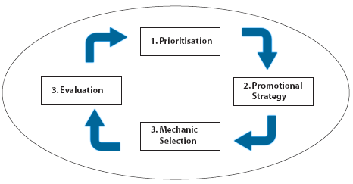

- Prioritisation
The better understanding a company has of promotions, the more investment can be optimised. It is imperative that suppliers know how promotionally responsive the category is. The higher the loyalty a category has, the less promotionally sensitive it is.
- Promotional Strategy
Before a promotional mechanic is chosen, there must be a clear promotional strategy that meets the aim of ‘what change in consumer/shopper behaviour is desired’. This should be in line with the category strategy and in turn will also be in line with the retailer’s and supplier’s corporate strategies.
- Mechanic Selection
It is imperative that the promotional mechanic chosen will result in driving the desired behaviour i.e. increase penetration, grow average weight of purchase, improve frequency.
- Evaluation
It is important that the performance of promotions are evaluated to inform future promotional activity. The evaluation stage is not only about the financial impact but the impact on shoppers should also be considered. For example, did the activity impact the shopper behaviour intended (such as average weight of purchase).

